Validating a Serial Number
ActivInspire 1.4

- Log into www.prometheanplanet.com and log in with username and password. If you do not have one, select register.

- Click on the Support Tab, then select ActivInspire.


- Select Download ActivInspire at the bottom of the screen.



- Choose your language.

- Scroll down to bottom of next screen.

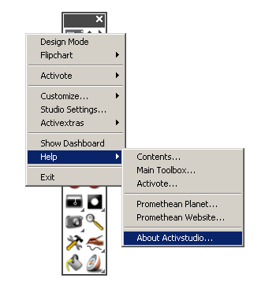
  - If you have the serial number and product code from the side of your board, select the Hardware tab and then fill in the blanks with your board’s information.
OR
  - If you have a serial number from the ActivStudio software (which is found under Main Menu <Help < About ActivStudio), click on Software Serial Number and plug in your serial number from ActivStudio.

Click on Validate and it will generate a new Inspire Serial Number for you.



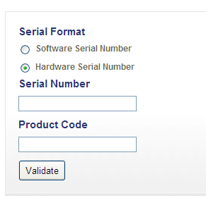

- When you open the software on your computer, fill in the license agreement with your information and your new ActivInspire serial number. Click “I accept…” and click OK.


