Name _________________________ Date __________________________

How Much Money?
How many coins? | How much is it worth?
____ pennies | ____ cents
____ nickels | ____ cents
____ dimes | ____ cents
____ quarters | ____ cents
____ half-dollars | ____ cents

Names of Students ______________________________________

Make 25 Cents
Pennies | Nickels | Dimes | Quarters

Name ____________________ Date___________________
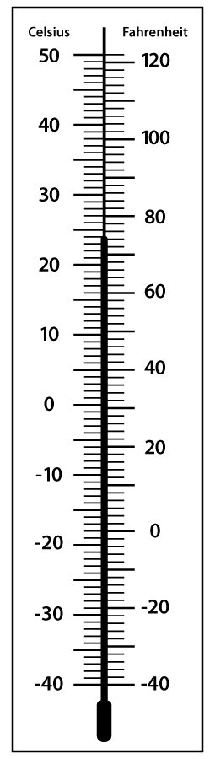

When I put the thermometer in hot water,

_______________________________________________.

When I put the thermometer in cold water,

_______________________________________________.

Place a collection of coins in front of the student. Ask and have the students respond to these questions/statements. Record the student’s responses.

Name these coins. Tell what they are worth.

Penny ____ ____

Nickel ____ ____
Dime ____ ____
Quarter ____ ____

Half Dollar ____ ____

Put together coins, initially putting like coins together. If the student knows how to count them, try mixing coins.

Can you count this money?

8 pennies _________
7 nickels _________
4 dimes _________
1 nickel and 5 pennies _________
2 dimes and 3 pennies _________
2 dimes, 1 nickel and 2 pennies _________
1 quarter, 1 dime, 2 nickels and 3 pennies_______

Comments:
______________________________________________________

______________________________________________________

______________________________________________________

Using old calendars, give the student a particular month. (any year will do)
Have the student use a page of the calendar to answer the following questions. The teacher will read the questions and determine if the student needs more instruction.

Name ____________________ Date ________________

1. What year is your calendar? __________________

2. What is your month? ____________________

3. How many days are in your month? ____________

4. How many Mondays are in your month? __________

5. How many Fridays are in your month? __________

6. On what day of the week is the 13th? ______________

7. On what day of the week is the 22? ______________

8. On what day of the week does your month end?

_______________________

9. What is your favorite day of the week?____________

10. Tell why it is your favorite? ___________________

________________________________________________

________________________________________________

