eleven  twelve  thirteen  fourteen  fifteen  sixteen  seventeen  eighteen  nineteen | ten  twenty  thirty  forty  fifty  sixty  seventy  eighty  ninety | one  two  three  four  five  six  seven  eight  nine

1 | 2 |  | 4 | 5 | 6 | 7 | 8 | 9 | 10
11 | 12 |  | 4 | 15 | 16 | 17 | 18 | 19 | 20
21 | 22 |  | 24 | 25 | 26 | 27 | 28 | 29 | 30
31 | 32 | 33 | 34 | 35 |  | 37 | 38 | 39 | 40
41 | 42 | 43 | 44 | 45 | 46 | 47 | 48 | 49
51 |  | 53 | 54 | 55 | 56 | 57 | 58 | 59 | 60
61 | 62 | 63 | 64 | 65 | 66 | 67 | 68 | 69 | 70
71 | 72 | 73 | 74 |  |  | 77 | 78 | 79 | 80
81 | 82 | 83 | 84 | 85 | 86 | 87 | 88 | 89 | 90
91 | 92 | 93 | 94 | 95 | 96 |  |  |  | 100

I know that _______ goes in this space because
number

_________________________________

1 | 2 | 3 | 4 | 5 | 6 | 7 | 8 | 9 | 10
11 |  |  | 14 | 15 | 16 | 17 | 18 | 19 | 20
21 | 22 | 23 | 24 | 25 | 26 | 27 | 28 | 29 | 30
31 | 32 | 33 | 34 | 35 | 36 | 37 | 38 | 39 | 40
41 | 42 | 43 | 44 |  |  |  |  |  | 50
51 | 52 | 53 | 54 | 55 | 56 | 57 | 58 | 59 | 60
61 | 62 |  | 64 | 65 | 66 | 67 | 68 | 69 | 70
71 | 72 |  | 74 | 75 | 76 | 77 | 78 | 79 | 80
81 | 82 | 83 | 84 | 85 |  |  | 88 | 89
 | 92 | 93 | 94 | 95 | 96 | 97 | 98 | 99 | 100

I know that _______ goes in this space because
number

_________________________________

1 | 2 | 3 | 4 | 5 | 6 | 7 | 8 | 9 | 10
11 | 12 | 13 | 4 | 15 | 16 | 17 | 18 | 19 | 20
 | 22 | 23 | 24 |  | 26 | 27 |  | 29 | 30
 | 32 | 33 | 34 | 35 | 36 | 37 |  | 39 | 40
 | 42 | 43 | 44 | 45 | 46 | 47 |  | 49 | 50
 | 52 | 53 | 54 | 55 | 56 | 57 | 58 | 59 | 60
61 | 62 | 63 | 64 | 65 | 66 | 67 | 68 | 69 | 70
 |  |  |  |  |  |  |  | 79 | 80
81 | 82 | 83 | 84 | 85 | 86 | 87 | 88 | 89 | 90
91 | 92 | 93 | 94 | 95 | 96 | 97 | 98 | 99 | 100

I know that _______ goes in this space because
number
_________________________________________________________

_________________________________________________________

________________________________________________________.

Name ____________________________ Date _______________________

Name of item Estimate tens & ones Actual tens & ones
__________________ | Tens Ones ____ | Tens Ones _____
Write number word:
__________________ | Tens Ones ____ | Tens Ones _____
Write number word:

__________________ | Tens Ones ____ | Tens Ones _____
Write number word:
_________________ | Tens Ones ____ | Tens Ones _____
Write number word:
__________________ | Tens Ones ____ | Tens Ones _____
Write number word:

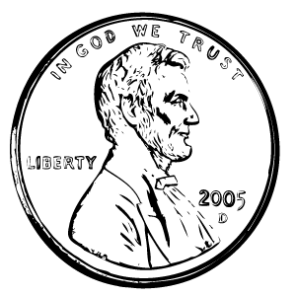

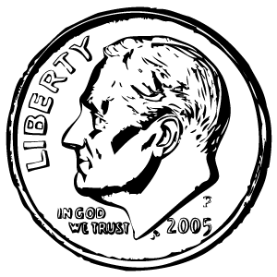

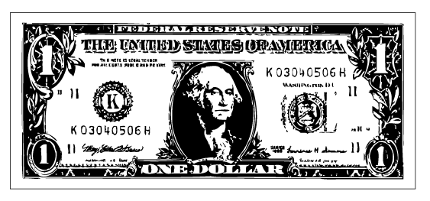

Name ______________ Date _______________

I used ______________s to measure.
type of manipulative
_________________________________________________________

Shape ___ I estimate it will be ______.
letter
I found out it was ________.

Number ____ Number word: _________________

Shape ___ I estimate it will be ______.
letter
I found out it was ________.

Number ____ Number word: _________________

Shape ___ I estimate it will be ______.
letter
I found out it was ________.

Number ____ Number word: __________________

Shape ___ I estimate it will be ______.
letter

I found out it was _______.

Number ____ Number word: ___________________

Teacher Note: This interview is to be used throughout the unit to gather information on students’ understanding of place value to determine which students need more instruction.

Place 33 loose linking cubes all the same color in front of the student. These are the
questions or instructions for the student being interviewed:.

How many cubes do you think are in this pile?

- Number less than 20 or more than 50
- Number between 20 and 40

Please put these in piles or sticks of tens and ones.

0 Can not complete the task
1 Completes the task

Do you know how many there are altogether?

- Begins to count by ones or says no/can’t
- Counts 10, 20, 30, 31, 32, 33. Answers 33

If student does not know the answer to the above question, ask:
“Can you count them by tens?”

- No or says 10, 20, 30, 40
- Counts 10, 20, 30, 31, 32, 33

Scoring Rubric for Place Value Interview

3 or 4 - Student demonstrates understanding of counting tens and ones

2 or 1 - Student does not seem to understand the concept of counting tens and
ones and needs to be targeted for more instruction.

Teacher Note: Provide the student with a number to use.

Name ______________________Date ________________

1) _________ ________ ________ ________________________________
number tens ones number word

2) _________ ________ ________ ________________________________
number tens ones number word

3) _________ ________ ________ ________________________________
number tens ones number word

4) _________ ________ ________ ________________________________
number tens ones number word

5) _________ ________ ________ ________________________________
number tens ones number word

6) _________ ________ ________ ________________________________
number tens ones number word

7) _________ ________ ________ ________________________________
number tens ones number word

Points | Name Date
3 | Student meets all of the objectives of the project.
2 | Student meets many, but not all of the objectives of the project.
1 | Student meets some of the objectives of the project.
0 | Student does not seem to understand the concept.

