docs.google.com

Word processing, spreadsheets, presentations, forms, and drawings. Allows users to collect and share information; anywhere, anytime access with a built-in chat feature.

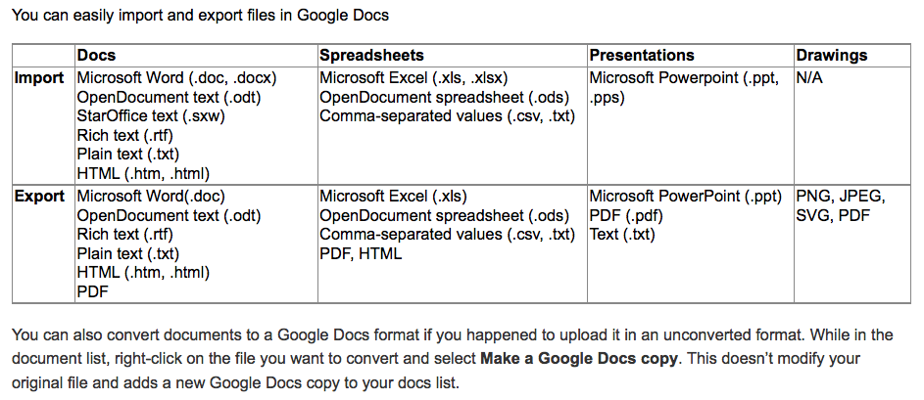

Documents, presentations, and drawings are all published as an HTML file, just like a webpage.
Spreadsheets, however, can be published as multiple types including:
- HTML
- CSV (comma separated values)
- TXT (Plain text)
- PDF
- XLS (Microsoft Excel)
- ODS (Open Document Spreadsheet

When publishing a spreadsheet, Under 'Get a link to the published data, ' you can select a format from the drop-down menu to get a unique public URL for the sheets or range of data you've selected to publish.

You can stop publishing documents at any time, just follow these steps:
- Open the doc you'd like to publish.
- Click the Share drop-down menu on the top right of the page and select Publish to the Web....
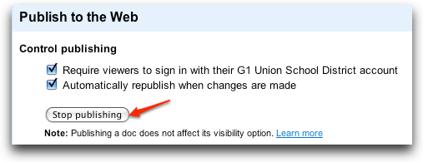
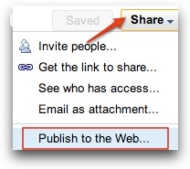
- Click the Stop publishing button.

Now anyone clicking the link to the published doc will no longer be able to access it.

Settings include:

Owners
- Can edit documents, spreadsheets, presentations, and drawings, and invite more editors and viewers.
- Can delete documents, spreadsheets, presentations, and drawings, and thereby remove access for editors and viewers. Please note: To fully delete a document, spreadsheet, presentation, or drawing, and remove access to it, you need to delete it and then Empty Trash.
Editors
- Can edit documents, spreadsheets, presentations, and drawings.
- Can invite or delete other editors and viewers (if the owner has given them permission).
- Can export a copy of the document, spreadsheet, presentation, or drawing to their local hard drive.
- Can view the list of editors.
- Can make a copy of a doc, and copy the list of doc's editors.
Viewers
- Can see the most recent version of a document, spreadsheet, presentation, or drawing but can't make any changes.
- Can export a copy of the document, spreadsheet, presentation, or drawing to their local hard drive.
- Can not view the list of editors.
- Can make a copy of a doc, but can't copy the list of doc's editors.

5 Visibility Options:

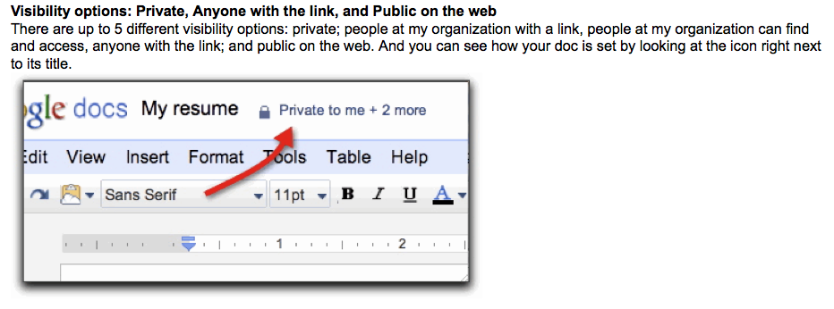

Private
When you create a private doc, you are the only person with access to it. And from there, you can grant access to other people. Anyone trying to access the document will have to sign in to their Google Account to verify that they have access to the doc. Private is the best setting for your own private documents, like a list of contacts or a resume. It's also good if you want to collaborate within a closed circle of people -- for example, if you and a friend or family member are working together on a private letter or working on taxes.
People at your organization with the link
Docs set to this option are accessible to anyone inside the domain who knows the URL of the file. If you also select the ‘Allow anyone to edit’ option, anyone with the URL will be able to view and edit your file. This option allows you to easily copy and paste the file’s link into chat, email and calendar invites for quick access and feedback.
People at your organization can find and access
Docs set to this option will be indexed by Google Docs search and may be opened by anyone in your organization.
If your Google Apps administrator allows sharing outside of your organization, you will also be able to make a file Public on the web or available to Anyone with the link (no sign in required). Administrators can also control the default visibility setting from the control panel.
Anyone with the link (must be enabled by Google Apps administrator)
A doc set to Anyone with the link is like an unlisted phone number. In the same way that anyone who knows an unlisted phone number can call it, anyone who knows the web address of a doc in this category can view it. If you also select the 'Allow anyone to edit' option, anyone with the URL will also be able to view and edit your document. Sign-in is not required, so viewers and editors may show up as anonymous.
Anyone with the link is a great setting if you want to give easy access to information to a bunch of people (as long as the contents of the doc aren't sensitive). For example, if you want to share a syllabus and a book list, you could put that info into doc set to anyone with the link and send your students the link. Docs in this category are generally not indexed by search engines, but they may show up in search results if the doc URL appears on another webpage that is indexed.
Public on the web (must be enabled by Google Apps administrator)
Set a doc to public if you want to make it publicly available to anyone. Public docs may get indexed by search engines (like Google Web Search), can show up in search results, and anyone who finds the web address of the doc can access it. If you also select the 'Allow anyone to edit' option, anyone that finds the document will also be able to view and edit your document.
Public on the web is a great setting if you're trying to get the word out about something. For example, you could create a flyer for a school event, save it as a public doc, post a link to it on your blog, and maybe ask other teachers or students to do the same.

Here's how to add specific editors and viewers:
- Open the doc you want to share.
- Click Share in the upper-right corner of the doc.
- At the bottom of the Sharing settings window, under 'Add people,' type the email addresses of the people you want to share with. You can add a single person, multiple people, or even choose from a list of your contacts.
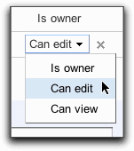
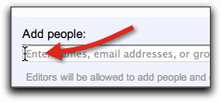
- To the right of the list of names, choose 'Can view' or 'Can edit' from the drop-down.

- Two quick options to consider (to share with default settings, feel free to skip this note):
  - By default, people who can edit your doc will also be able to share it with additional people. You can remove that ability by clicking Change next to 'Editors will be allowed to add people...' before you click Share.
  - By default, everyone you share doc with will get an invitation email. If you'd rather not notify them, un-check the 'Send notifications' box. They'll have access the next time they sign in.

- Click Share.

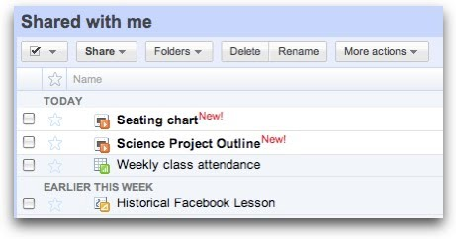
When you share the document with an individual directly, they will notice the document appear in their Google Docs doclist, with New placed next to the document name, and the document name bolded.
If they do not see the doc yet, they may need to refresh their doclist.
.

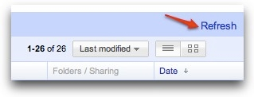

If you selected to have an email notification sent, the individual will receive an email message with a link to the shared document:
