Flip Camera Instructions

When you plug in your camera, the software automatically opens. You will see all the videos in the Camcorder window.
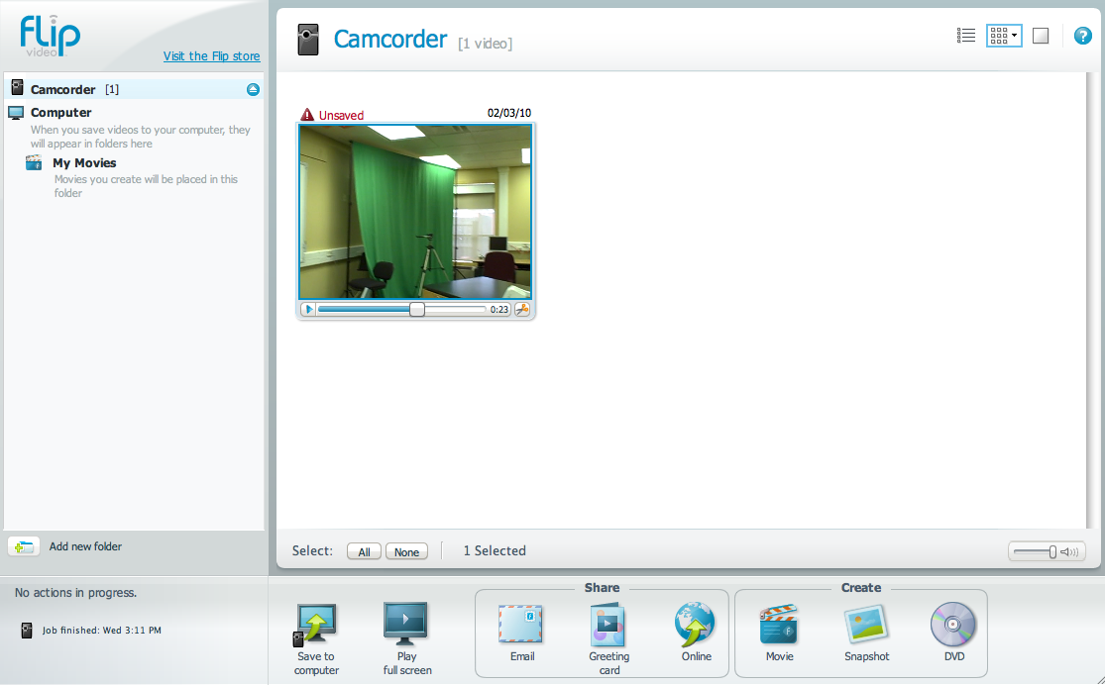

Options of what to do with a video:
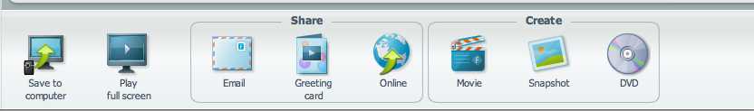
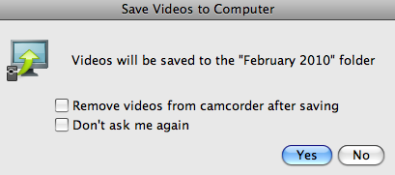
- Save to computer – gives you an option to
“Remove your videos from the Flip”

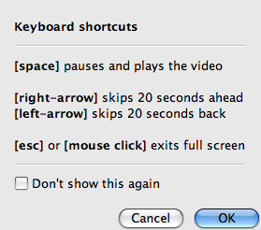
2. Play full screen -

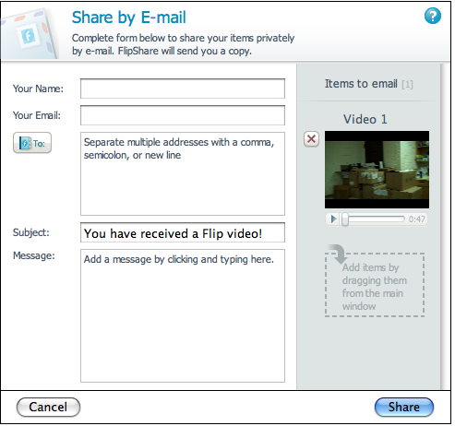

3. Email – tip: check the size of the video before sending!
- Flip Channel – similar to RSS (podcasting) 5. Greeting Card – a wizard walks you through the
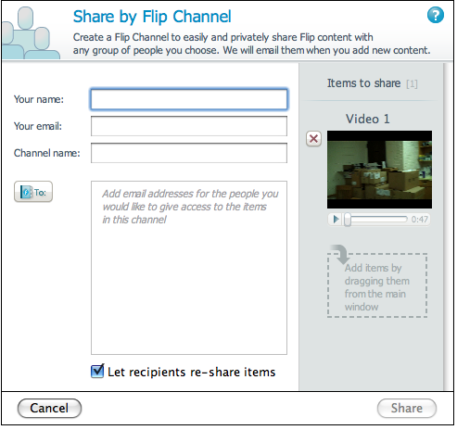
steps. Your video plays within the theme. You
will be given an opportunity to email your video.
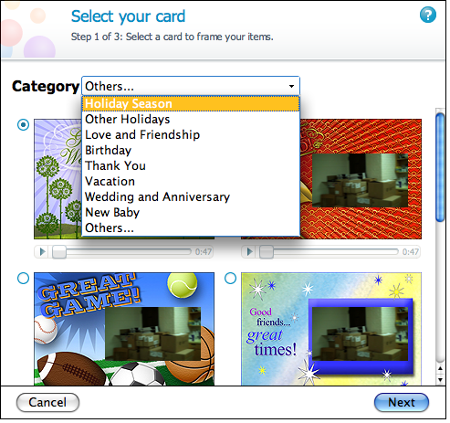

- Online – share your videos online 7. Movie - you can make your own titles, credits,
(a wizard will walk you through the steps) add music, etc.
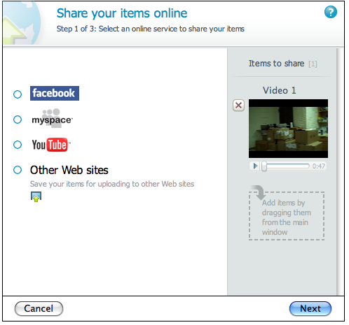
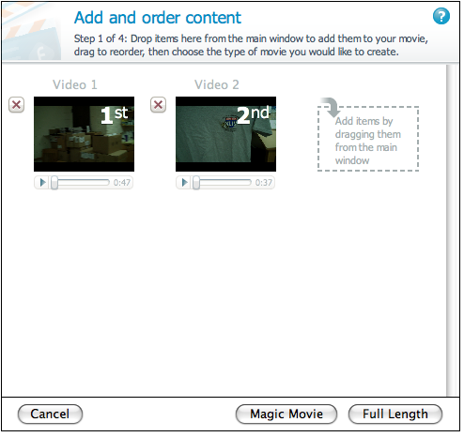

Note: Magic Movie option will take a random segment of each of your video clips and put together all the segments, including snapshots and previously made movies.

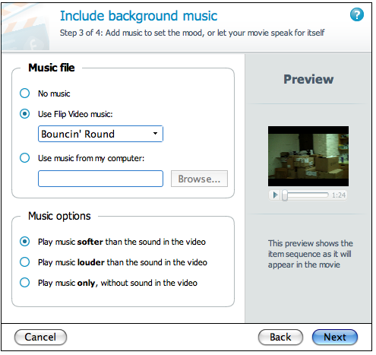
Add title and credits: Add background music:
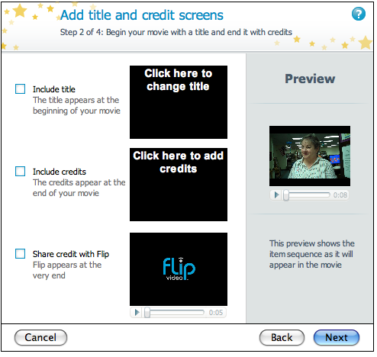

Name your movie: 8. Snapshot – allows you to take a snapshot of any
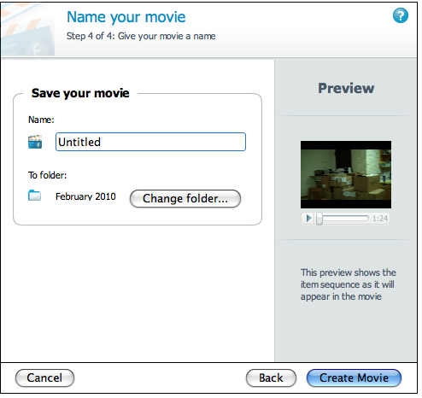
part of the movie (snapshots are saved in “My
Pictures”)
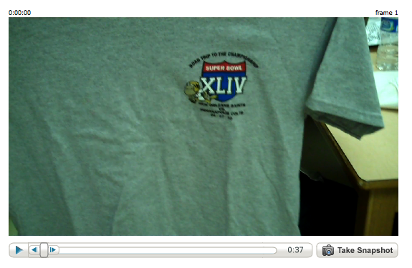

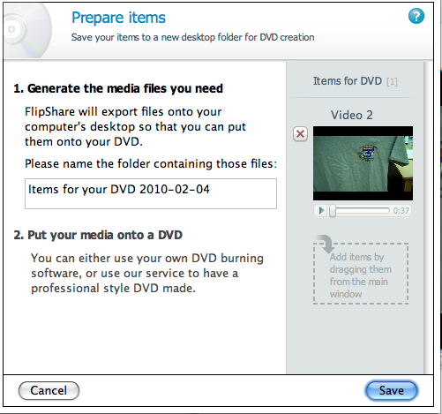
9. DVD

