Downloading Flipcharts from Promethean Planet

- Go to www.prometheanplanet.com.

- Click Register to create username and password. You will only need to register the first time you visit the website. Be sure to remember your username and password.

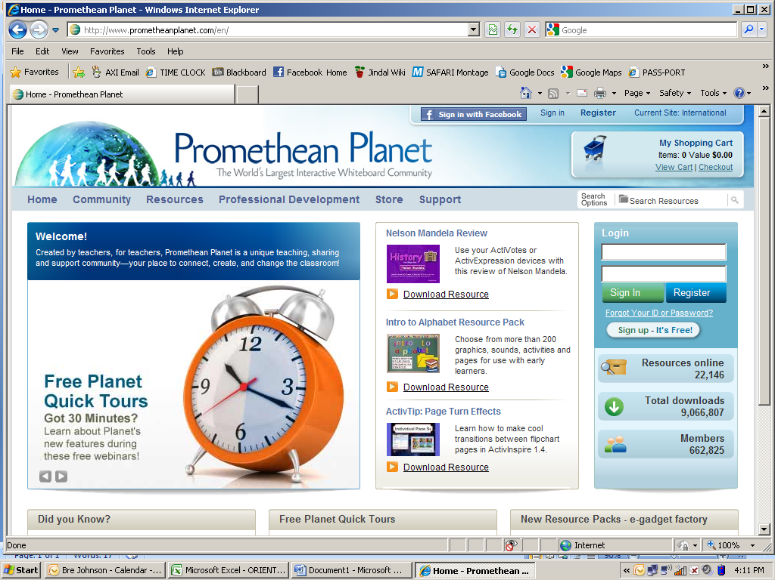

- In the Search Options, type in a keyword (ex: fractions) (see above).

- Click on the options along the left side of the screen to narrow your search. Then, select Filter at the bottom.

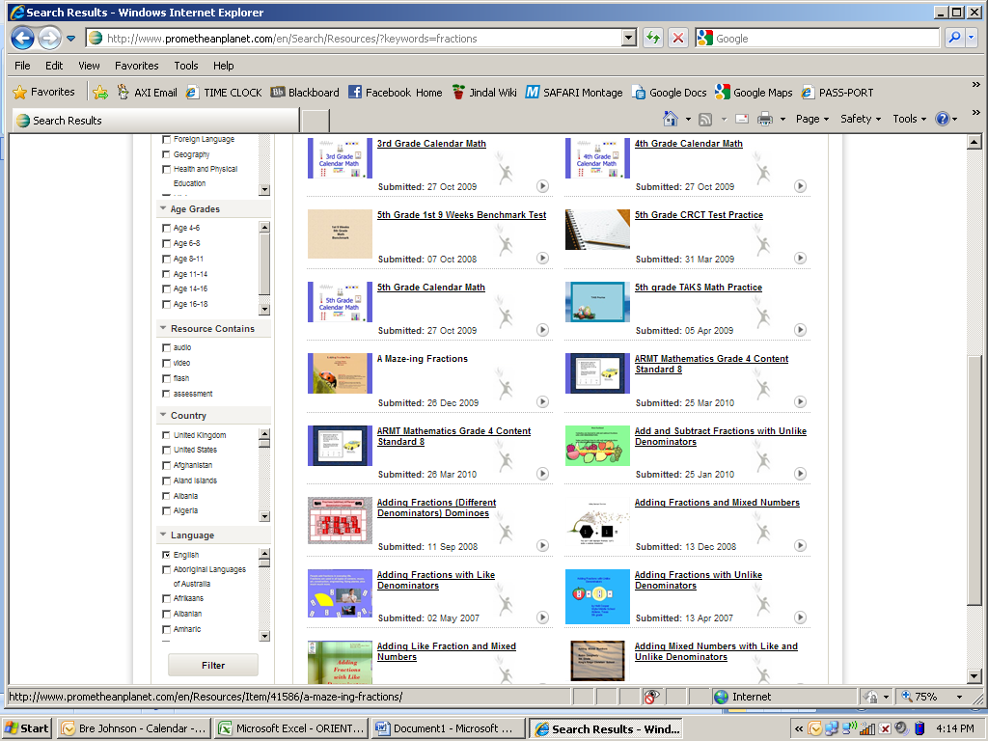

- Click on any of the flipchart icons on the screen to take a closer look.

- You can view a slideshow of the flipchart to see if it is something you could use in your classroom. If you do not like it, go back and type in another search. Do not click the back button in your browser.

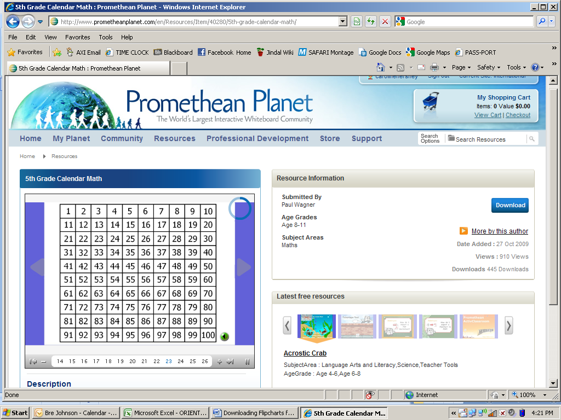

- To download, click the blue download link on the right side of the screen (see above).

- You will then be asked to Save or Open. If you want to preview the flipchart first, choose open. If you know you want to save the flipchart, select save. If ActivInspire is already open, you will need to click on the software down in the task bar to view the flipchart.

- You can view the flipchart by going through the pages using the arrows in your toolstrip.

- If you decide you like the flipchart, go up to File < Save. You will want to make sure you are saving to a location you will remember. You may want to create a new folder to save all your flipcharts in.

