Downloading ActivInspire 1.4

- Go to www.prometheanplanet.com and click on the Support tab. Then click ActivInspire under Software. If you not created an account, you will need to click Register to create a username and password.
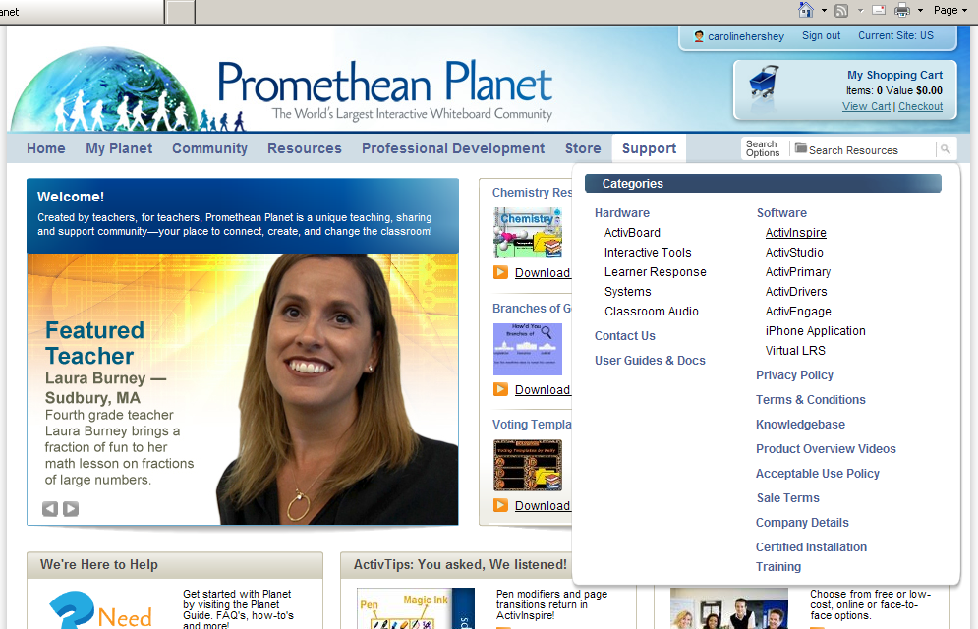

- Click on the Download ActivInspire tab.
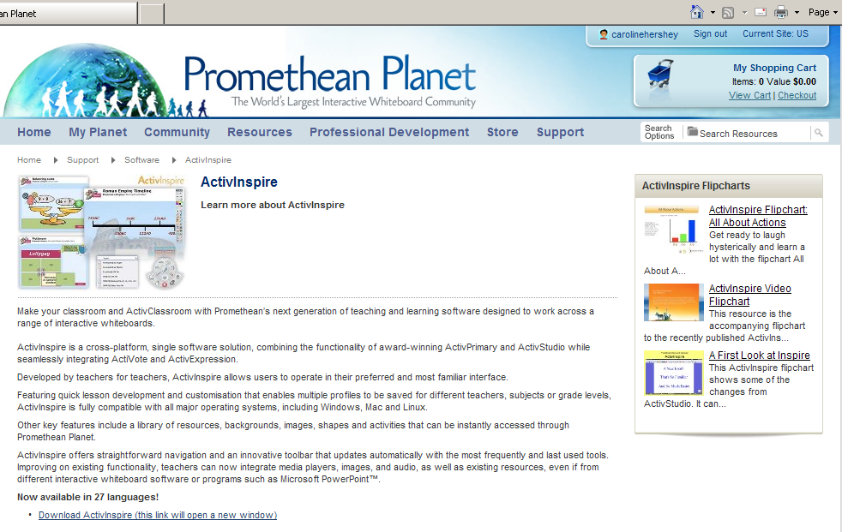

- Click on your language.

- Click Download Version 1.4.
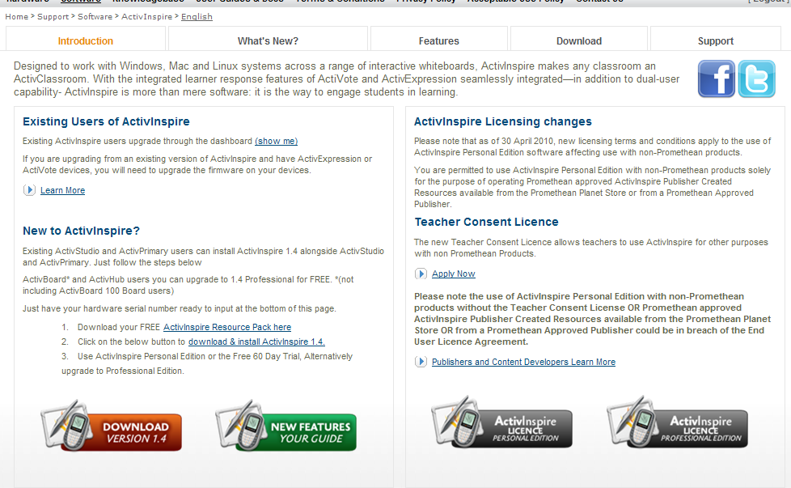

- Click Download Version 1.4.
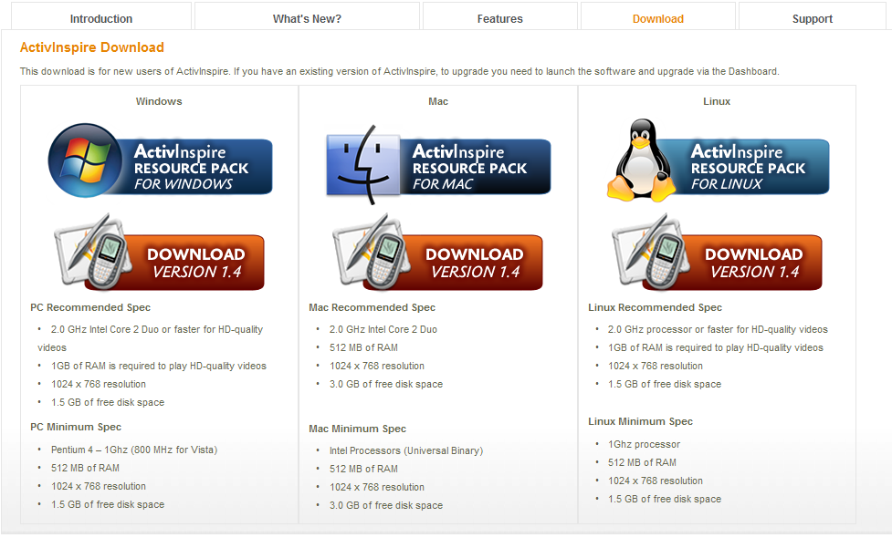

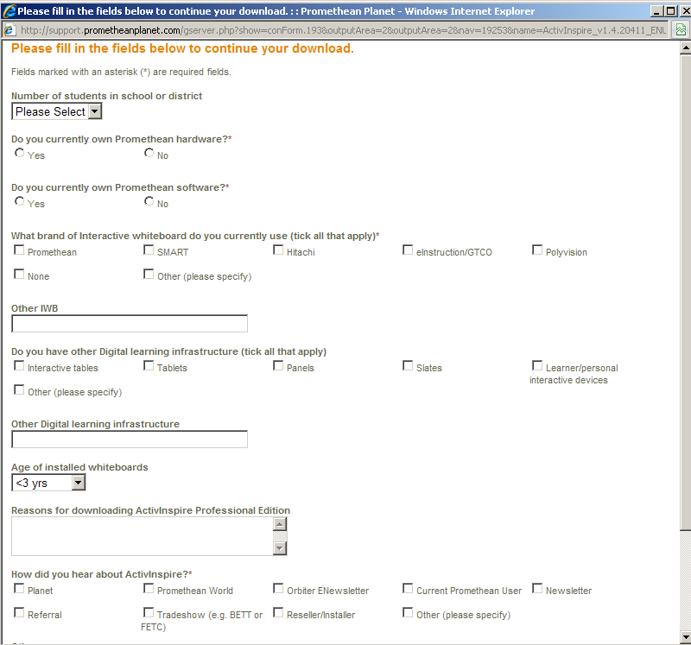
- Complete survey.

- If using a Windows machine, the security bar will pop up along the top of your window. Click on the bar and click Download File.

- Click Run to download the software. Walk through the download process.

- Once downloaded, the ActivInspire icon will be on the desktop. Double click to open.

- The Promethean Licensing Agreement will appear. Type in any User Name and Organization. Type in the serial number from the sticker you received on your bag you received with your new Promethean ActivBoard. Next, check the box to agree to the terms and select OK. Each serial number can be used on up to five computers.

- The first time you open ActivInspire, this box will appear. K-2 teachers may want to select Promethean ActivPrimary. 3-12 teachers will want to select Promethean ActivStudio.

- Once the software is downloaded, you will want to download the resources.
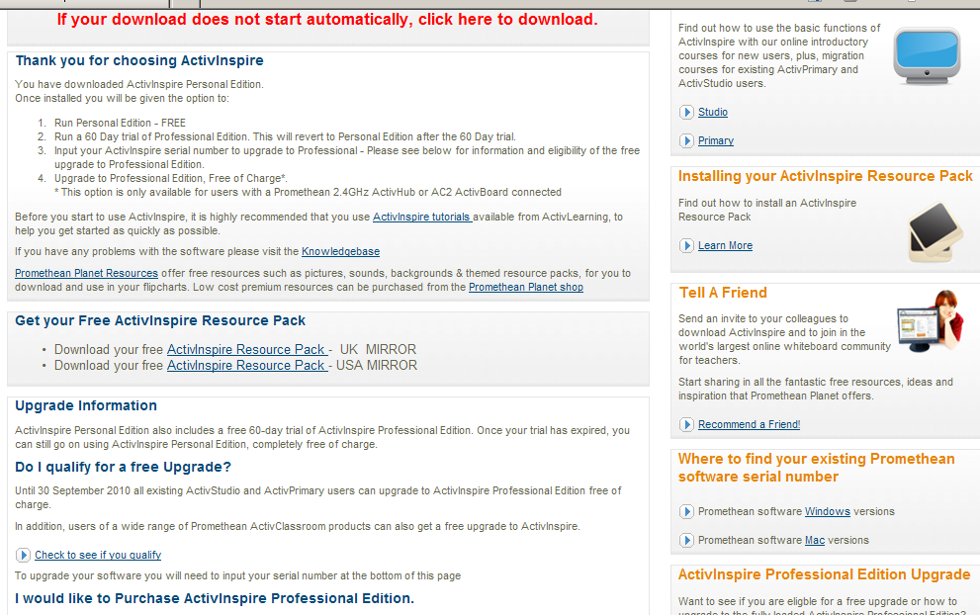

** If on a PC, you will need to click on the security bar and select Download File…

- Save the file on the desktop. Once downloaded, open ActivInspire. Go to File < Import < Resource Pack to Shared Resources. Select the file on the desktop and click open. Resources will import into software.

