Cleaning Your Filter
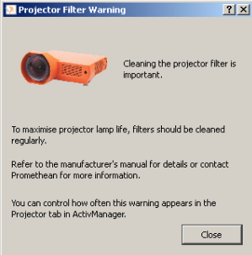

Seen this message yet? It will pop up every few weeks not knowing if you have or have not cleaned your filter.

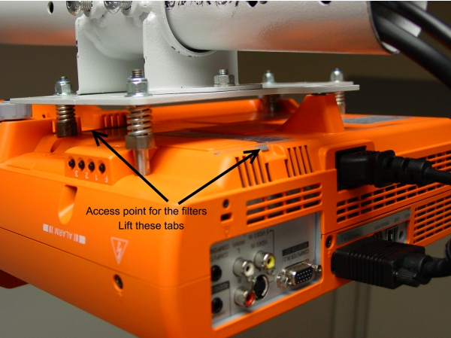
You will want to clean your filter every four weeks. It allows the projector to breathe and will preserve your bulb longer.
Here is a picture of where the two filters are located on your Promethean projector. If you do not have a Promethean projector, the filters may be in a different location.
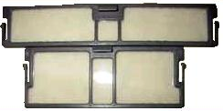

Here is what the two filters look like.

