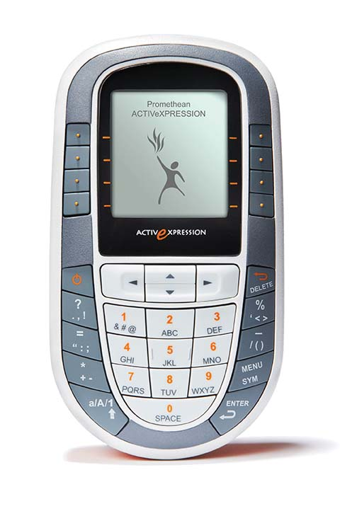
Quick Guide to Getting Started
- Take the small plastic piece out of the bottom of each device. This activates the battery in each device.

- Plug in the ActivHub into a USB port on the computer you are working on. Allow a few seconds for the computer to recognize the hub.

- Open the ActivInspire software. The first menu that pops up in the dashboard.

- On the dashboard, click Configure. Then choose Register Devices.

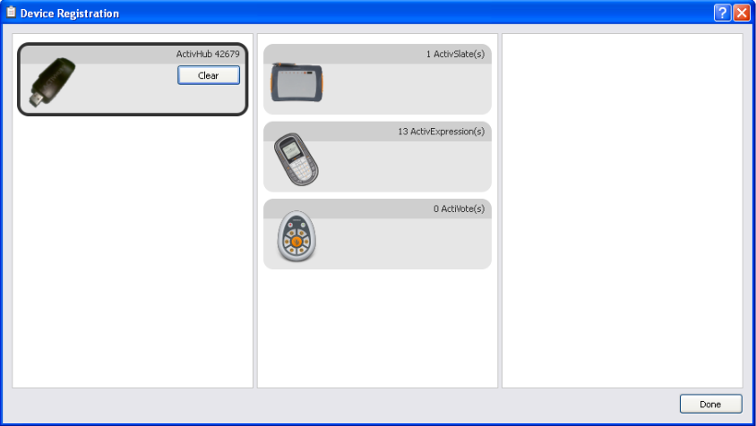
- You will see this screen.

- Click on ActivExpression(s)

- Choose the number of devices you are registering.

- Click Allow Expression end used naming so you can name each device.

- Next, follow the directions on the screen and apply to each device.
  - Power on each ActivExpression device
  - Press the MENU/SYM button
  - Choose Register on the top of the screen
  - Type in the 3 letter PIN on each device
  - Input number or name on each device (numbers recommended for anonymous voting)
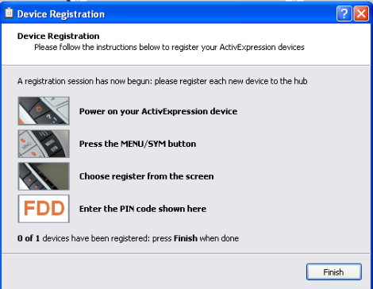
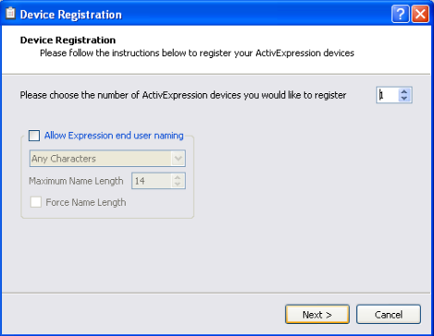
  - When all devices are registered, the screen below will disappear.

