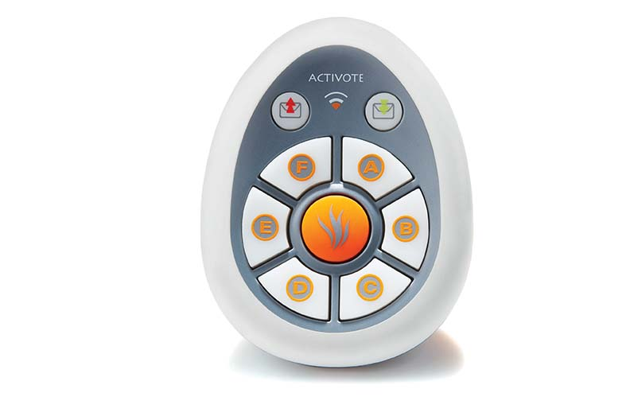
Quick Guide to Getting Started
- Take the small plastic piece out of the bottom of each device. This activates the battery in each device.

- Plug in the ActivHub into a USB port on the computer you are working on. Allow a few seconds for the computer to recognize the hub.

- Open the ActivInspire software. The first menu that pops up in the dashboard.

- On the dashboard, click Configure. Then choose Register Devices.

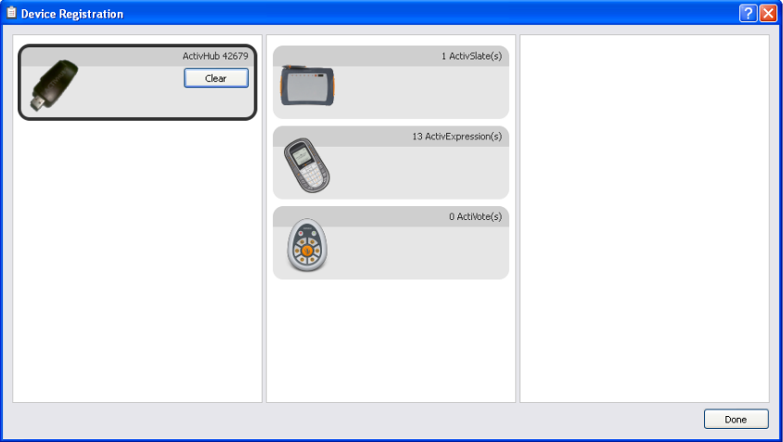
- You will see this screen.

- Click on ActiVote (s) Click Register.

- Choose the number of devices you are registering.

- Next, follow the directions on the screen and apply to each device.
  - Press and hold the central Registration button (orange flame)
  - The red and green lights turn on
  - Enter the 3-letter pin code on each device
  - Click Finish when all through with all devices
