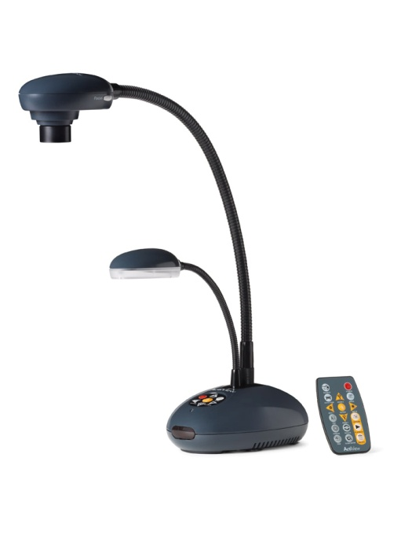
Quick Guide to Getting Started

- Connect power cord from ActiView to wall. Then, connect the ActiView to your computer by the USB cord. You do not need to connect the VGA.

- Load the ActiView software from the CD onto your computer while the ActiView is still connected by the USB. You will be prompted to restart your computer.

- Bringing the camera image into your flipchart
  - Turn on ActiView by pressing red power button.
  - Open ActivInspire, click on Insert > From Scanner/Camera
  - Select Visual Presenter V2 TWAIN
  - Adjust paper or object under camera (use zoom in/out button on ActiView)
  - Click capture on the screen. Image will be transferred into your current flipchart page. Image can now be edited in ActivInspire.

OR Annotate over live image
- Turn on ActiView by pressing Power icon
- Open the ActiView software on the desktop (shown below)
- Flame image will appear on desktop. Click on it to expand.
- Click the top left orange image to display the live image
- To annotate over live image, click Annotate icon. It will open the Annotation toolbox so you can annotate over your image.

ActiView Software

